**Ideation Phase**

**Define the Problem Statements**

|  |  |
| --- | --- |
| Date | 19 September 2022 |
| Team ID | PNT2022TMID43271 |
| Project Name | Ideation phase brainstorm & idea prioritization |
| Maximum Marks | 4 Marks |

**Introduction**

**Define is the second stage of the design thinking process, it is preceded by the empathy phase. This phase is about synthesizing observations about users from the empathy phase and defining an actionable problem statement. Defining the problem statement requires the articulation of the problem to establish a detailed problem statement.**

**Analysis**

## The Ideation Phase

**Ideation is perhaps my personal favorite stage in the design thinking process. Because it is the time when you can sit back and relax and let ideas come to you. You may come up with as many ideas as you can. And then work your way through them.**

**Or you could go for perfection in one main idea and try to manifest it. However usually we go for the former than the latter in the design thinking process. So that we could have a systematic approach to problem solving.**

**The ideation stage is all about generating ideas in bulk. And they must have diversity in their approach to solving the problem.**

**So at the beginning of the ideation stage, you must look for quantity and not quality in your ideas. And it is very crucial that you come up with as many ideas as you can. Because the next step would be to suspend on those ideas. So that people can let as many ideas out as they can with no restrictions.**

**It is important that everyone is able to voice their ideas on the table. As it ensures diversity and allows other people to come up with better ideas listening to others. So everyone’s involvement allows for better discussions.**

**And so it is very important because introverts often have great ideas but are reluctant to speak up. But if there is greater acceptance and proper time provided to speak you can get everyone’s involvement.**

**Now that the ideas are on the table, you must focus on novelty rather than relevance. It is simple to develop relevance but novelty is rare and must be valued. It is the novelty of ideas that is the sign of creativity.**

**Novel ideas must be further refined, developed, and enhanced to become relevant.**

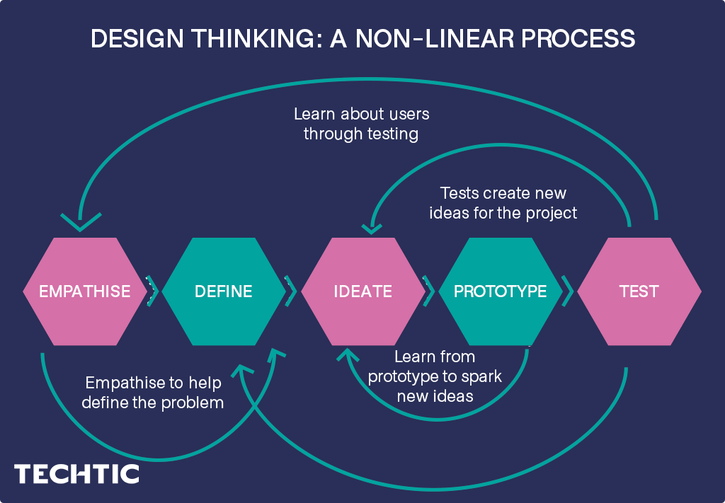

## Ideation Tools and Methods

**The most important part of the ideation stage is to get novelty out at the table. It is the balance between novelty and relevance where you come up with innovation. However relevance almost always exists so it is a novelty you must focus on more.**

**The techniques that ideation stage uses are many but here are some to list a few.**

### Mind Maps

**Mind mapping is a method that allows designers to visually create and connect ideas. So mind maps help you organize and remember information. The key to information is to use key words instead of sentences or descriptions.**

**Of course the key words must actually represent the idea. And mind maps are created like diagrams to ensure visualization of ideas. Since everyone has a unique mind, the mind maps look different for each individual.**

**Mind maps represent the actual brain’s way of thinking . So the patterns in the map represent information in a way that is logical to the viewer. Firstly you must identify the main core of the problem.**

**Then you must branch out all the individual factors of the problem. And make a connection between those factors. You may use color codes or pictures in order to connect the similarities between those factors.**

### Characteristics

**Characteristics process was created mainly by architects who are interested in generating a creative output. A key component of the characteristics is time compression. For four to seven days, participants work together in brainstorming sessions, sketching workshops, and other exercises through a series of feedback loops.**



# Python 3: Fibonacci series up to n

>>> def fib(n):

>>> a, b = 0, 1

>>> while a < n:

>>> print(a, end=' ')

>>> a, b = b, a+b

>>> print()

>>> fib(1000)

0 1 1 2 3 5 8 13 21 34 55 89 144 233 377 610 987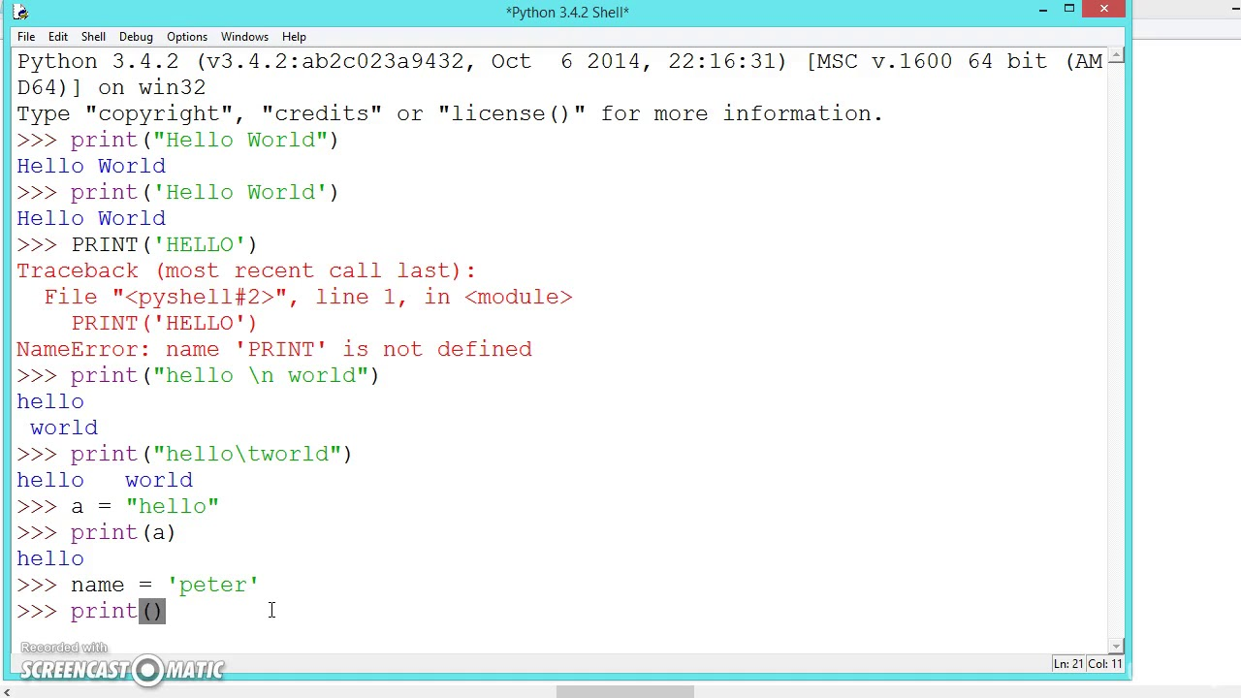

# Design Thinking Process: Define the Problem and Interpret the Results

**When you learn how to master the definition of your problem, problem statement, or**[**design challenge**](https://www.interaction-design.org/literature/topics/design-challenge)**, it will greatly improve your**[**Design Thinking process**](https://www.interaction-design.org/literature/topics/design-thinking-process)**and result. Why? A great definition of your problem statement will guide you and your team’s work and kick start the**[**ideation**](https://www.interaction-design.org/literature/topics/ideation)**process in the right direction. It will bring about**[**clarity**](https://www.interaction-design.org/literature/topics/clarity)**and focus to the design space. On the contrary, if you don’t pay enough attention to defining your problem, you will work like a blind man stumbling in the dark.**

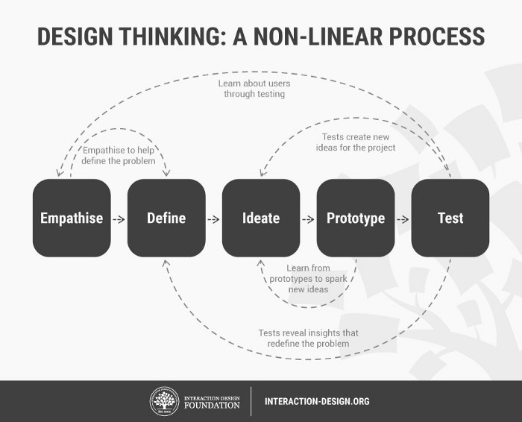

**Analysis** 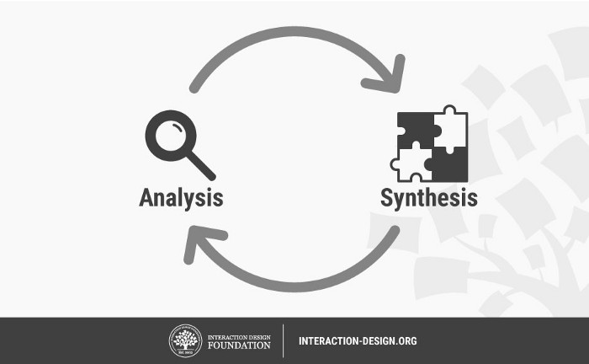

**Analysis** **is about breaking down complex concepts and problems into smaller, easier-to-understand constituents. We do that, for instance, during the first stage of the Design Thinking process, the stage, when we observe and document details that relate to our users. Synthesis**, **on the other**[**hand**](https://www.interaction-design.org/literature/topics/hand)**, involves creatively piecing the puzzle together to form whole ideas.**